|  |
| --- |
|  |



**E-Sanchay.**

Trade-in your used electronics for cash

Group B

NISHANT SINGH

Guided by - Mrs. Manjusha Ma’am

TYBBA (CA) Semester V Project - BMCC, Pune

|  |  |
| --- | --- |
| Names | Roll No |
| Rohit Tank | **53** |
| Ruturaj phozakalatt | **84** |
| Gayatri Shinde | **64** |
| Srushti Maskar | **37** |
| Krupa Patel | **45** |
| Ishita Kagathara | **29** |

**GROUP MEMBERS**

Table of Contents

INTRODUCTION 4

AIMS & OBJECTIVES 4

SCOPE 4

TECHNOLOGIES USED 5

DIAGRAMS 6

DATABASE TABLES 11

TESTING FUNCTIONALITIES 24

# 1. Introduction

Today the rapid expansion of technology and the consumption driven society is resulting in creation of very large amount of e waste. E Sanchay is an e waste management system where the seller of an e waste registers and uploads the details and image of the e waste like old Smartphone, television, pen drives, computer, etc on our website. A person and a vehicle would be sent to the address mentioned by the seller to pick up e waste. Then the e waste would be sent to the companies who would be refurbishing or recycling it.

## 2. AIMS & OBJECTIVES

1. To contribute towards our mother earth via sustainable goals for waste management
2. To create a safe, efficient, and effective e waste management and disposal system that protects the natural environment while supporting the city
3. To provide a user-friendly platform for the e waste transaction
4. To take care of user convenience and save their time.

## 3. SCOPE

Probably 10 years back when the producers made products which lasted longer, currently the products are made for you to dump. Most of the companies are making products that don’t have longer life so that you can discard them easily and buy new products. This means there will be more and more e waste generated and presently the e waste management infrastructure is not enough to handle this tremendous amount of waste. Hence the scope of our website is quite high. This can definitely be a profit-making business.

## 4. TECHNOLOGY USED

* BACKEND

1. PHP
2. MYSQL
3. PHP Mailer
4. FPDF(PDF library)

* FRONTEND

1. HTML
2. CSS
3. BOOTSTRAP

# Activity Diagram :

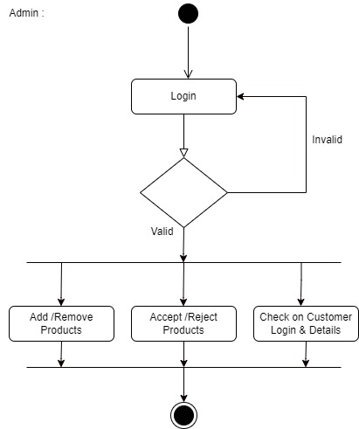

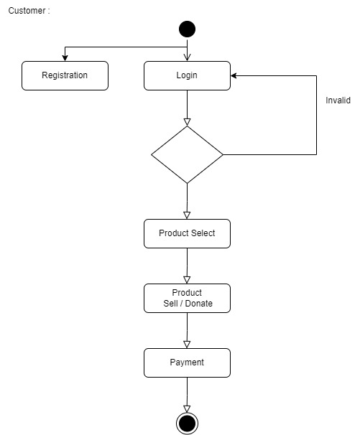

**Dataflow Diagram :**

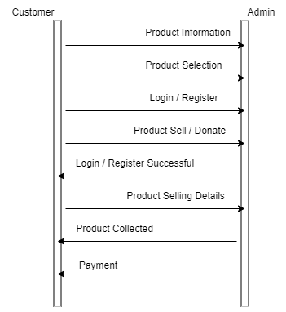

# Use Case Diagram :

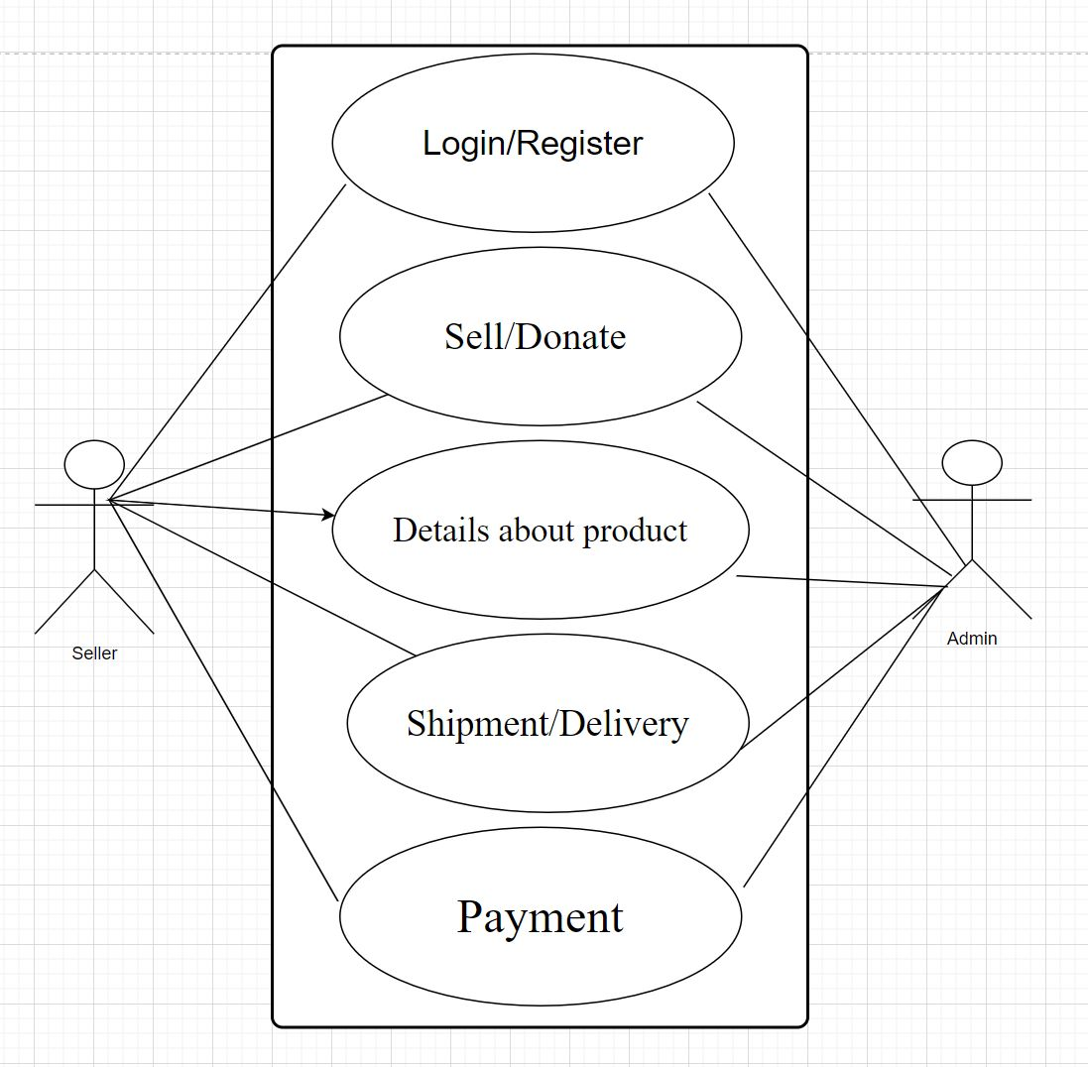

**Flow Chart :**

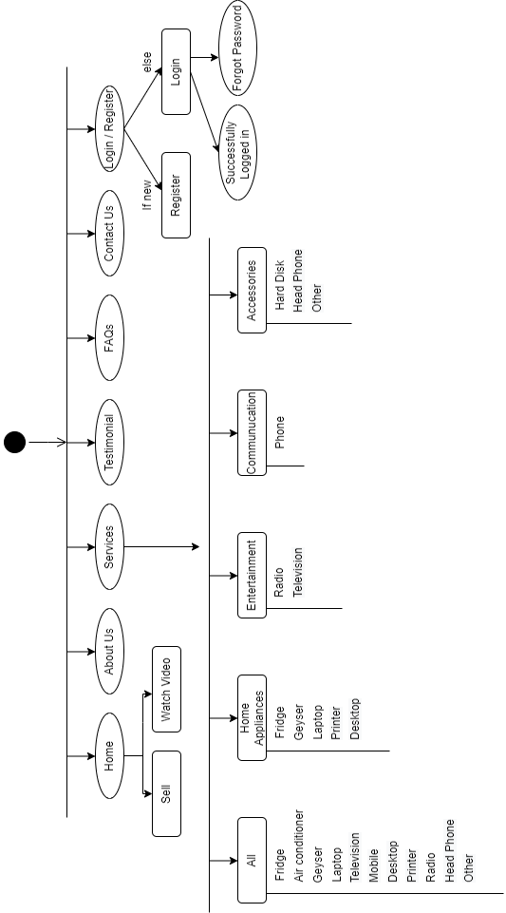

## . Database tables

## users table

## 

**products table**

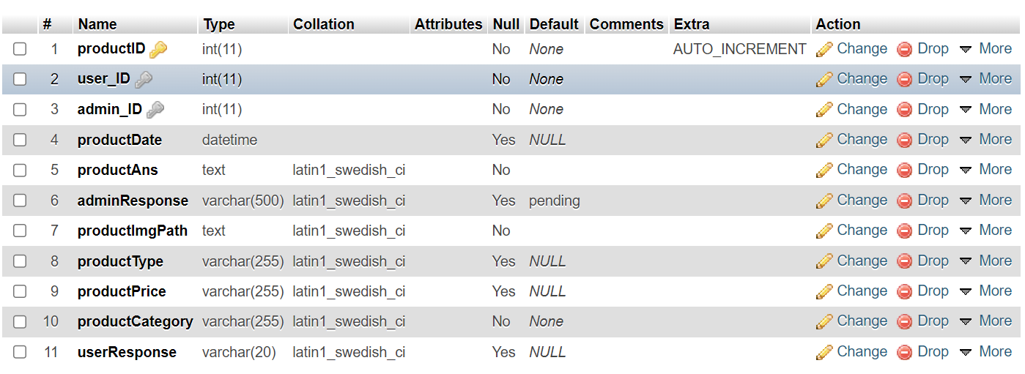

**contactus table**

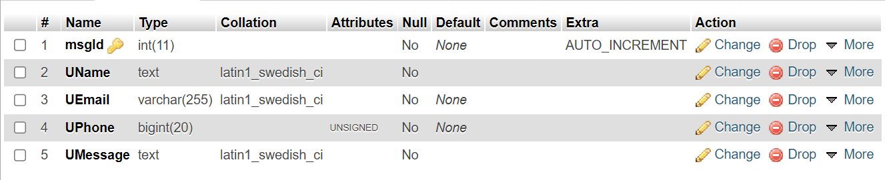

**User Manual**

1. **Landing Page**

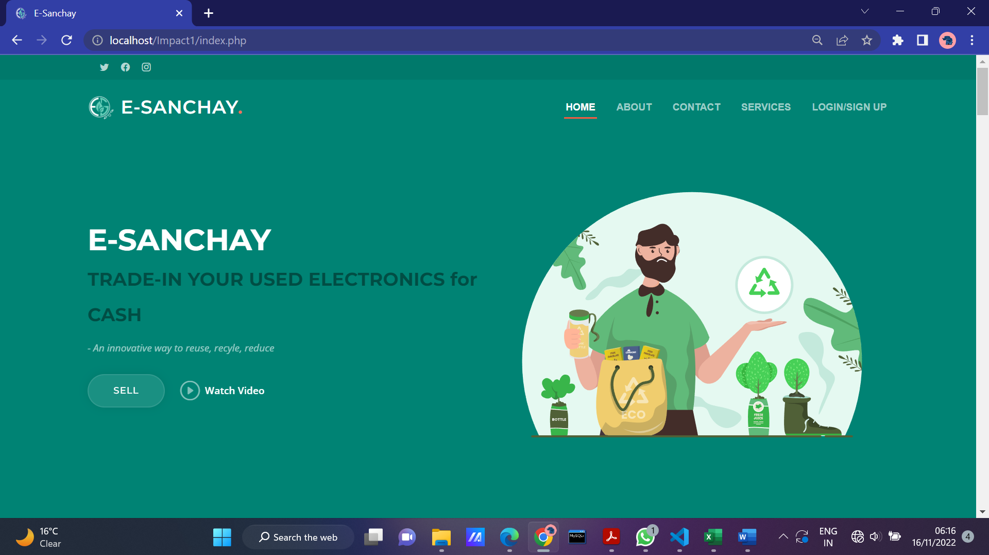

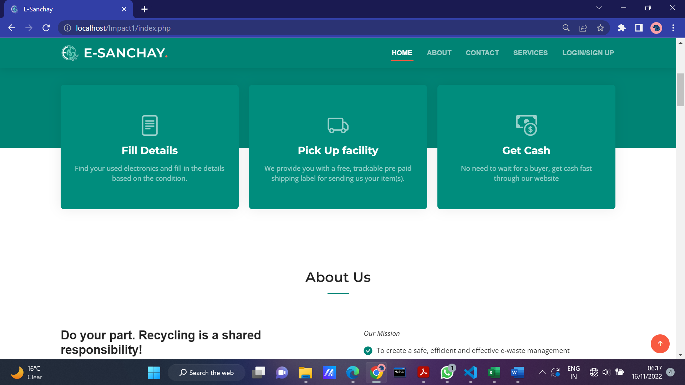

1. **About Us page**

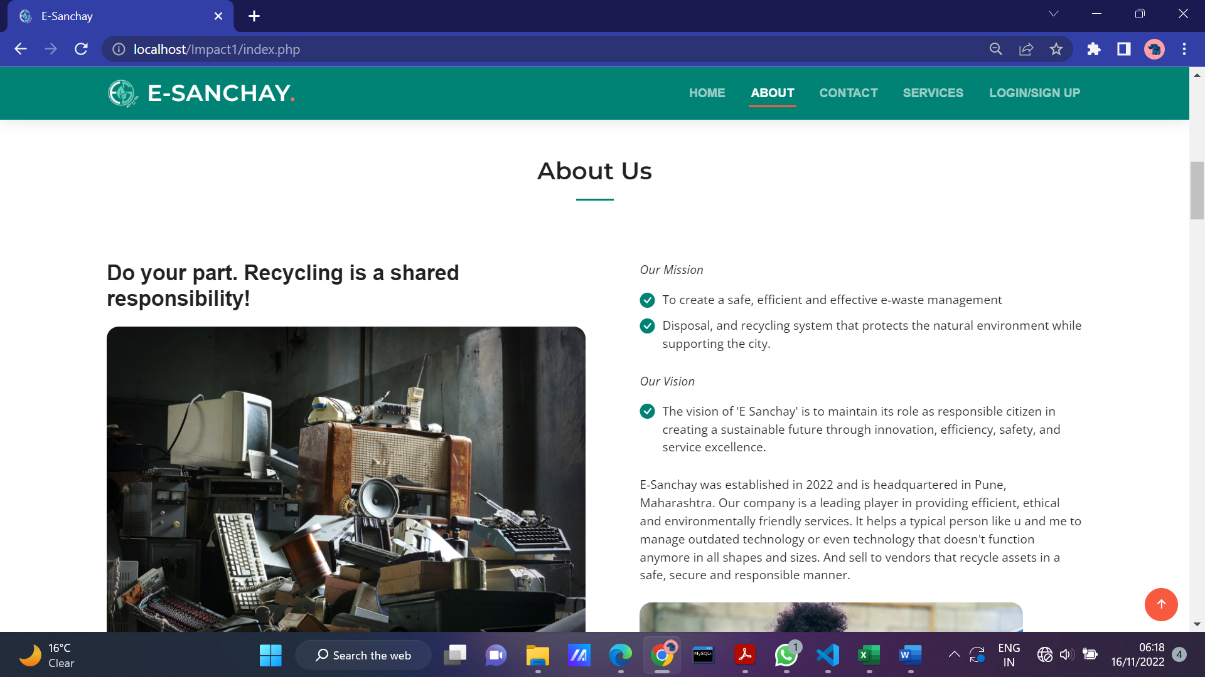

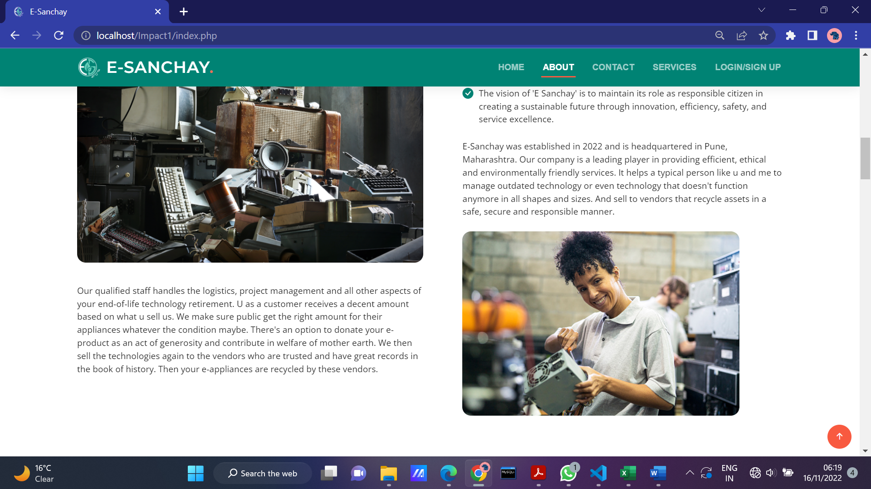

**3.TieUps with vendor’s section**



**4.Services page**

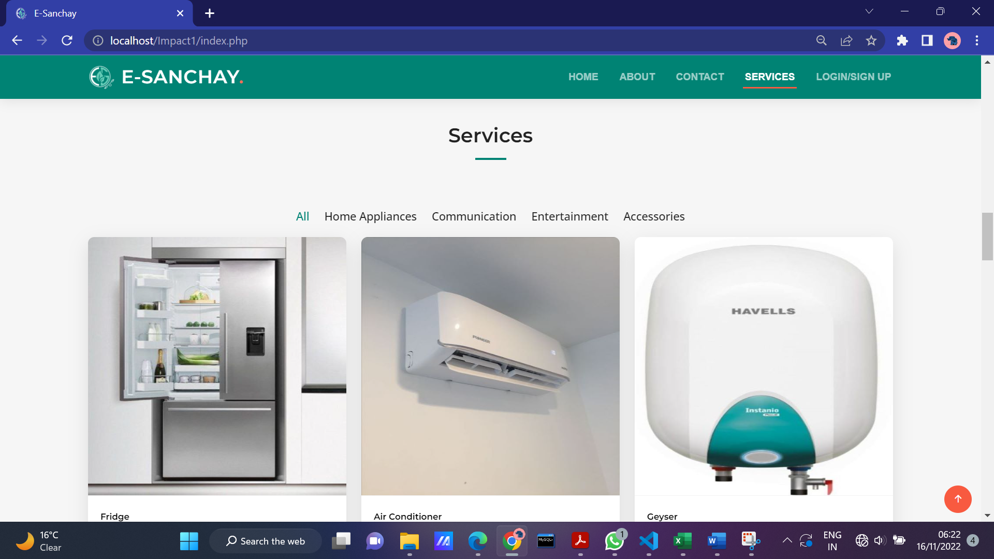

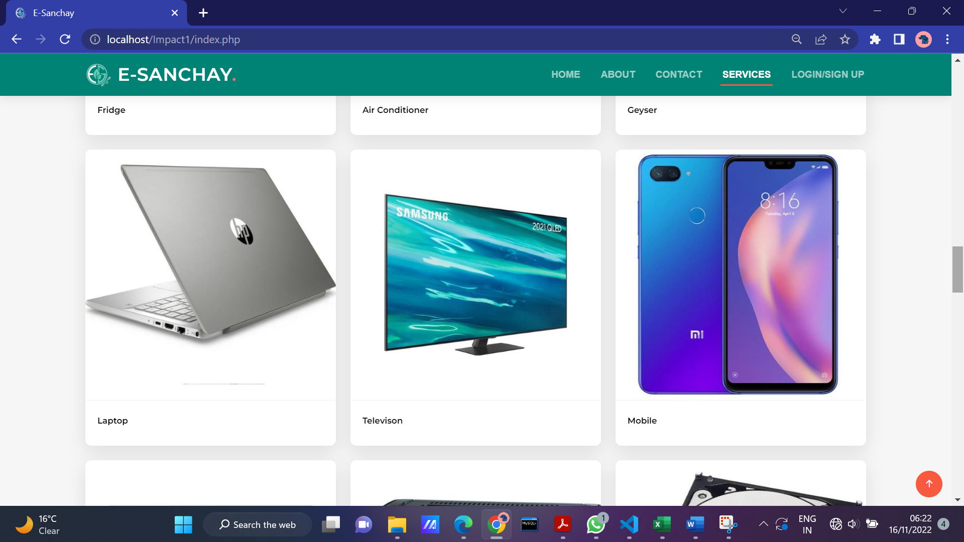

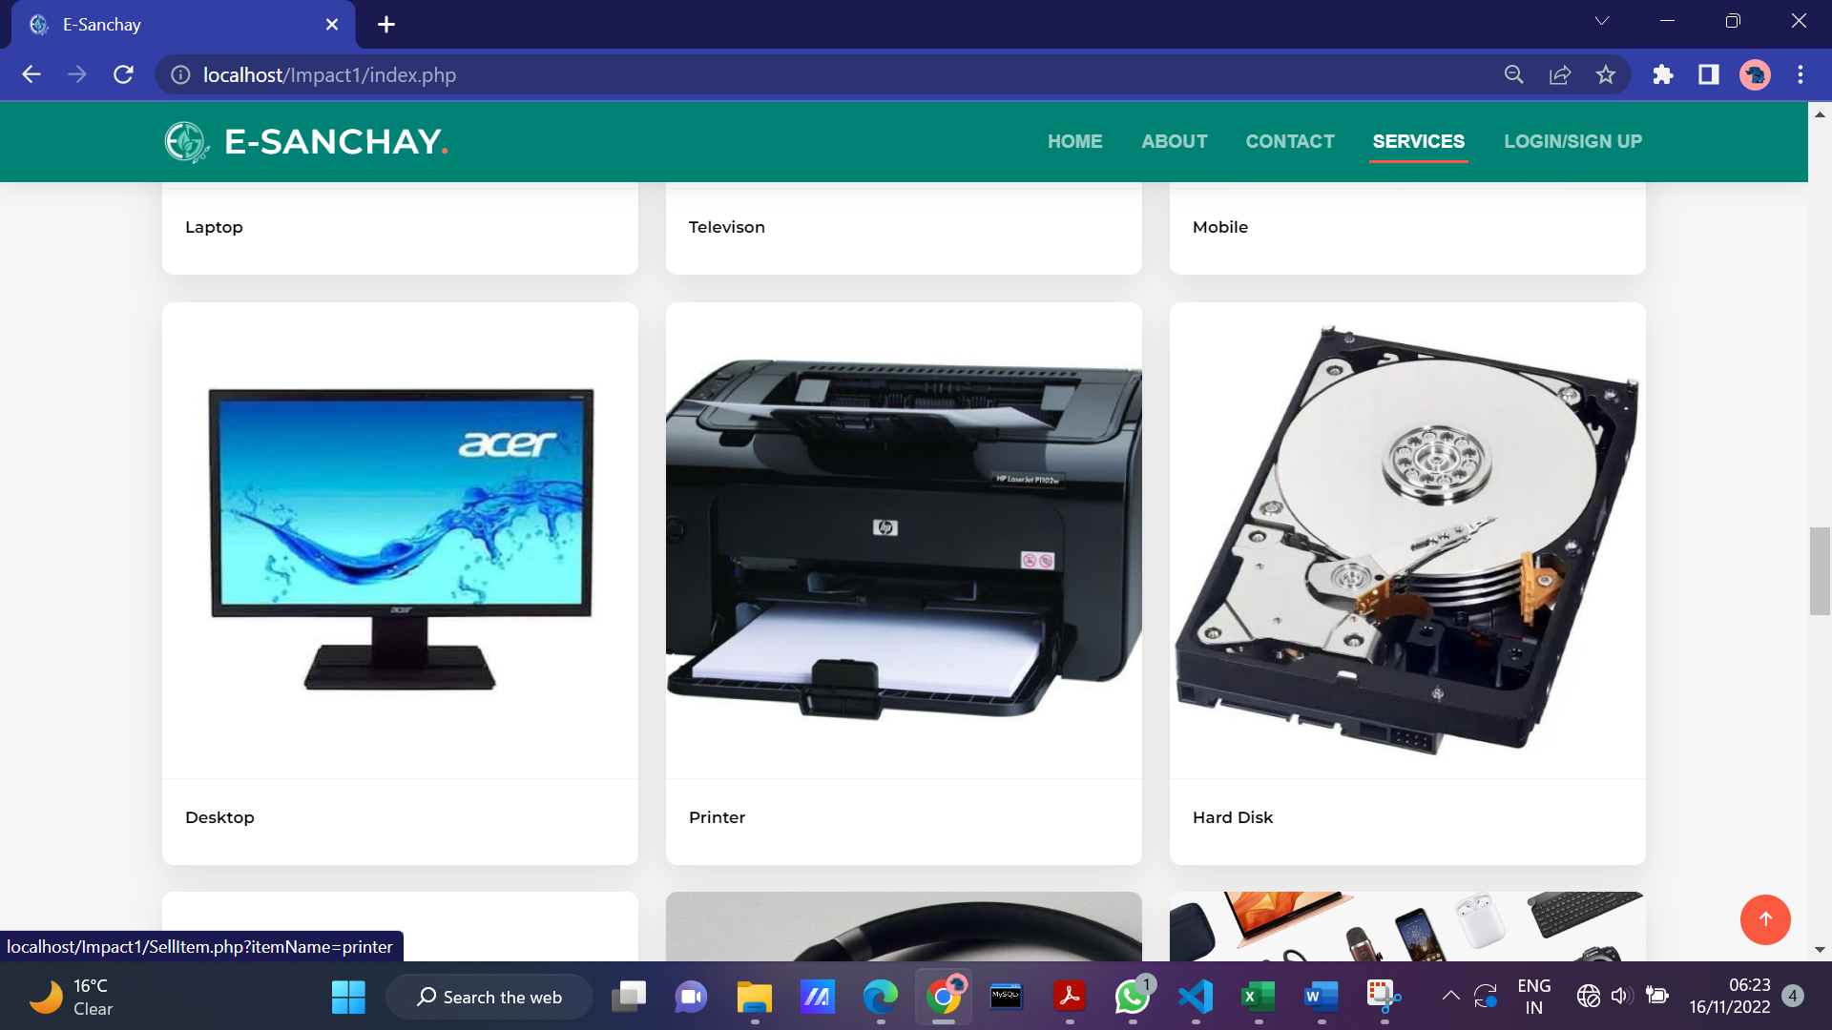

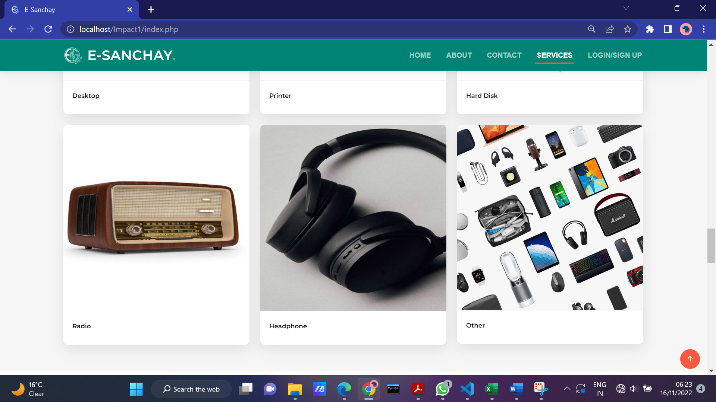

**5.Testimonials**

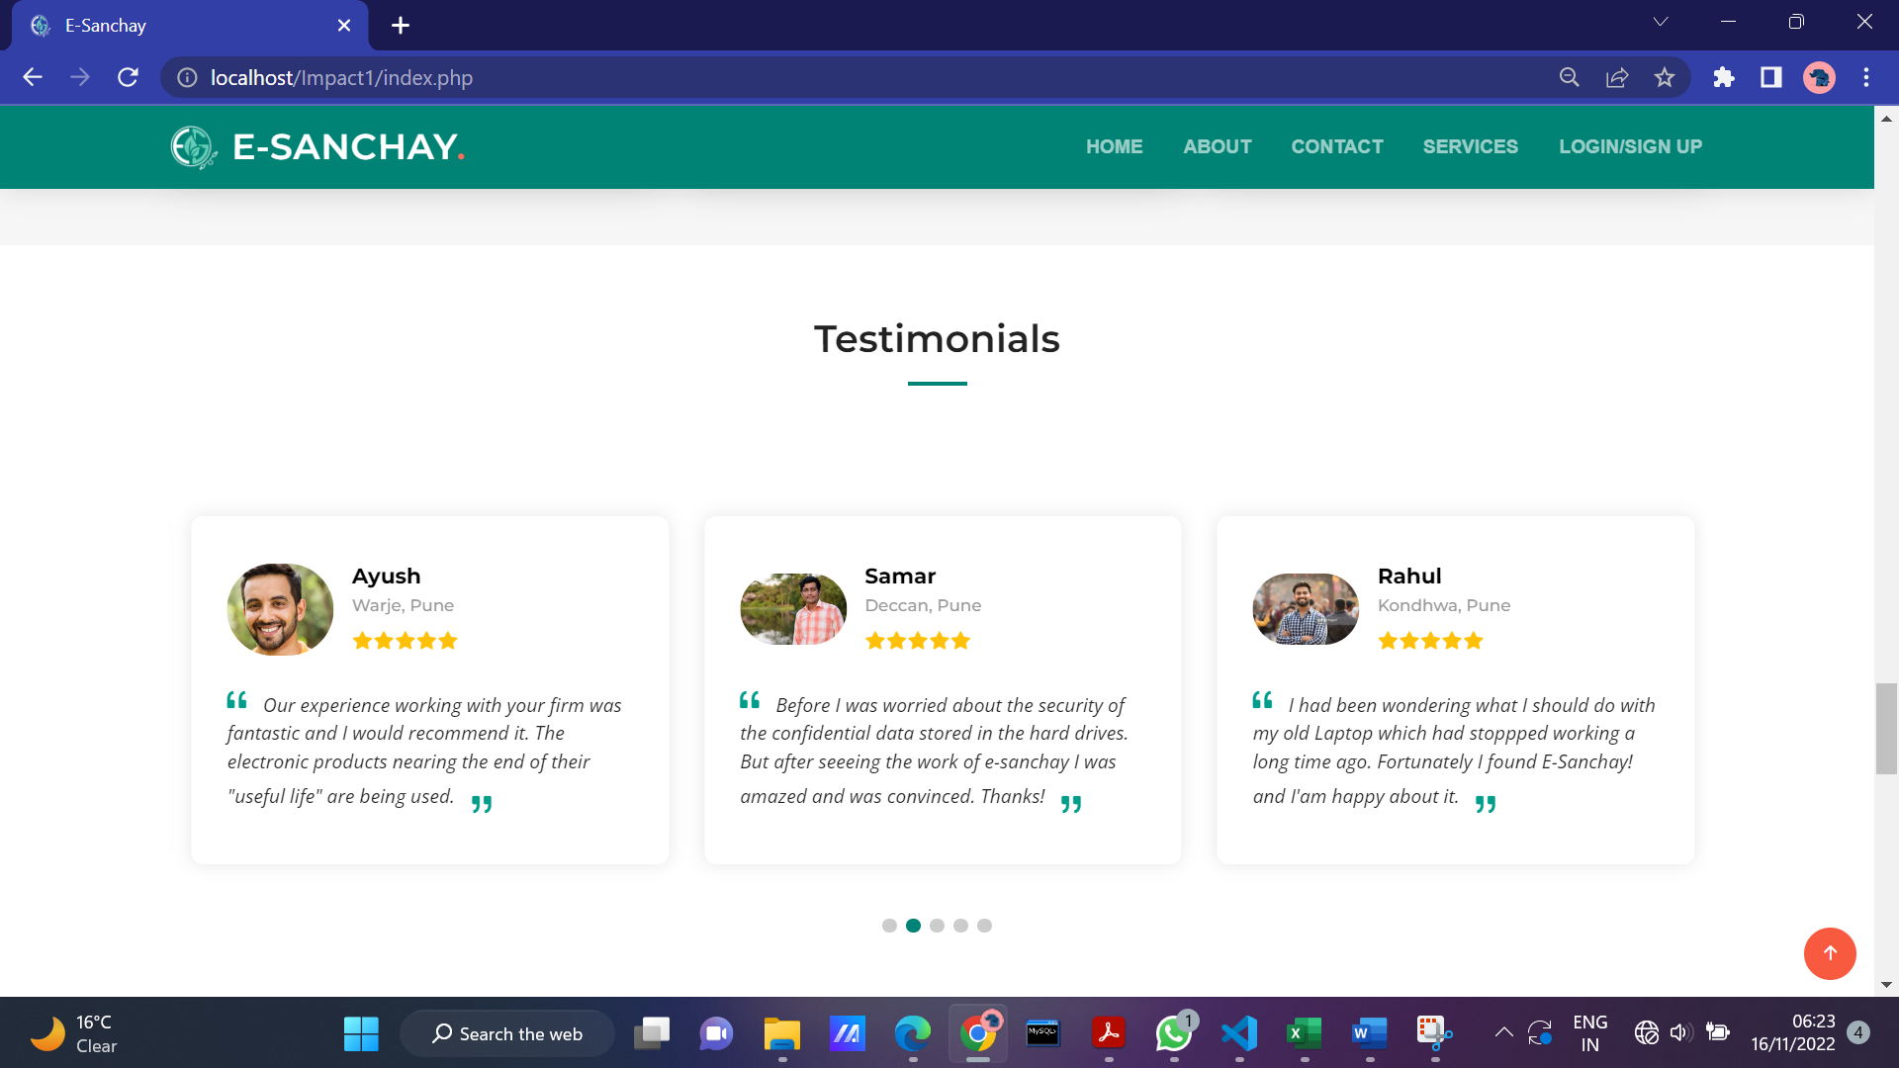

**6.FAQs**

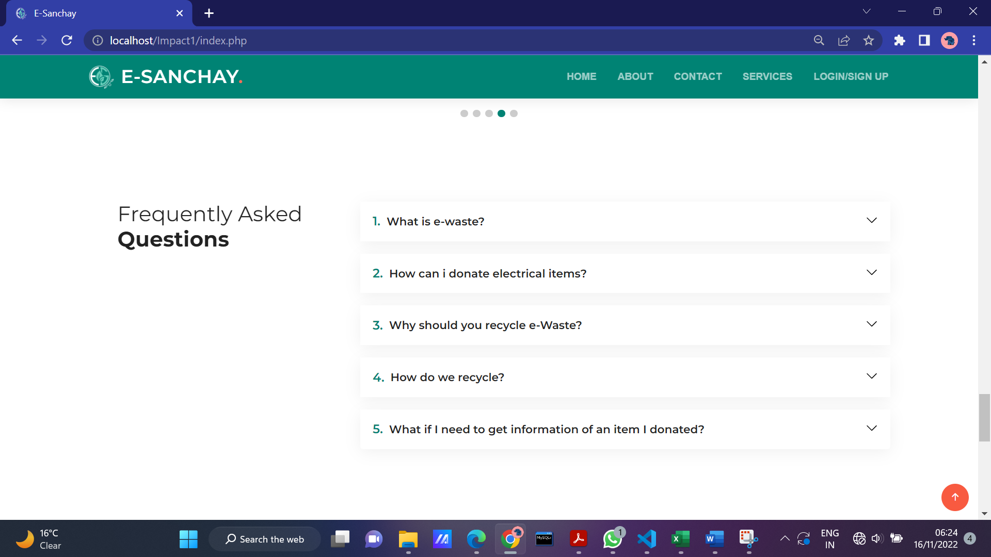

**7. Contact Us Page**

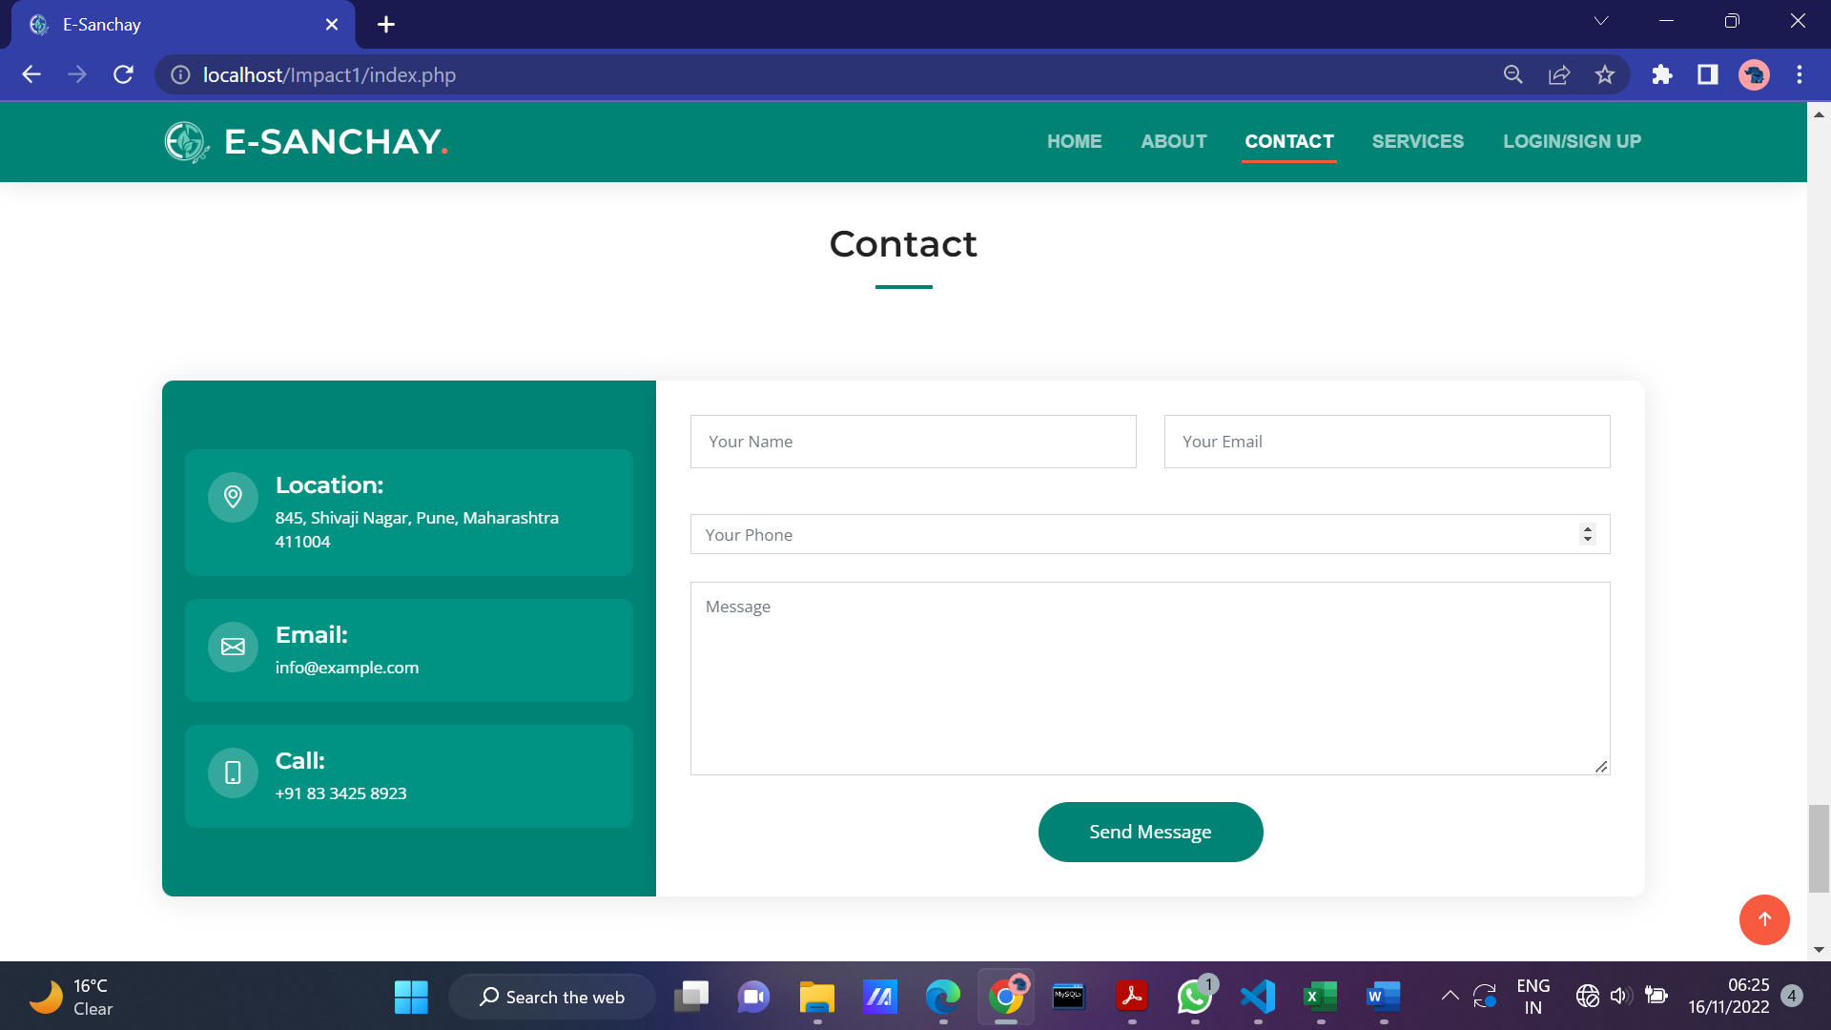

**8.Footer section**

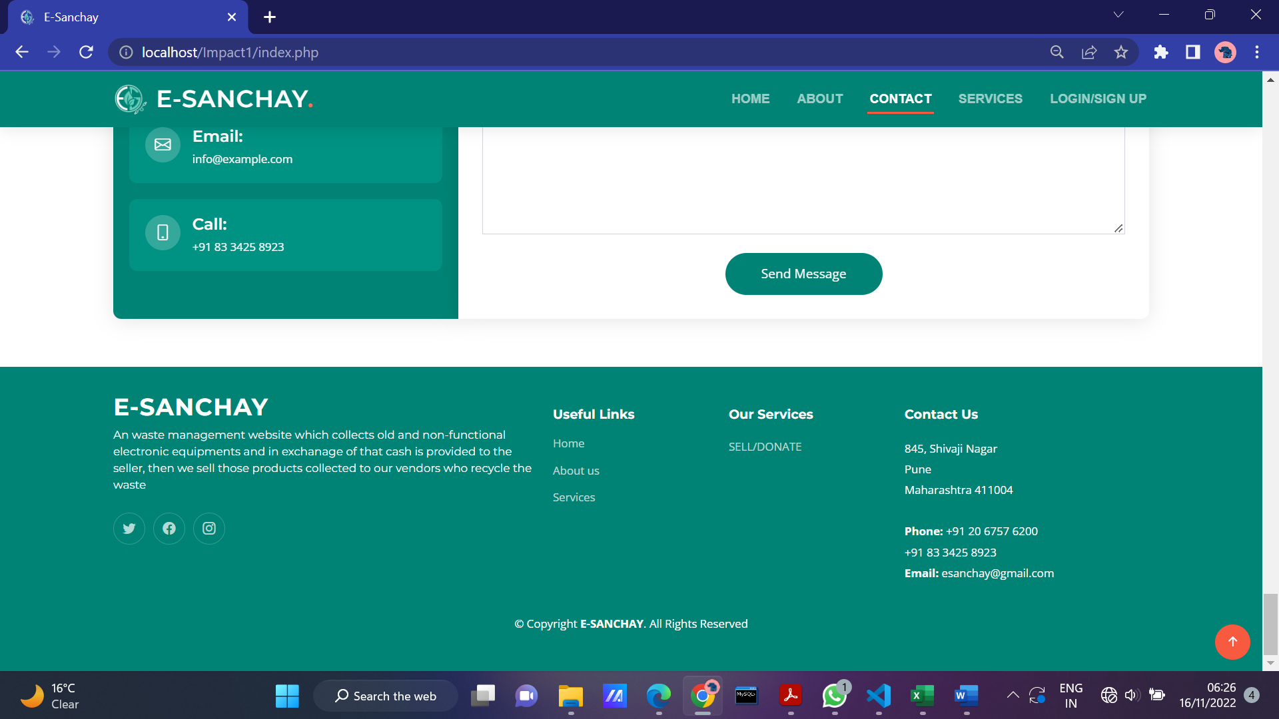

**9. Click on Services button-🡪Select the product to be sold**

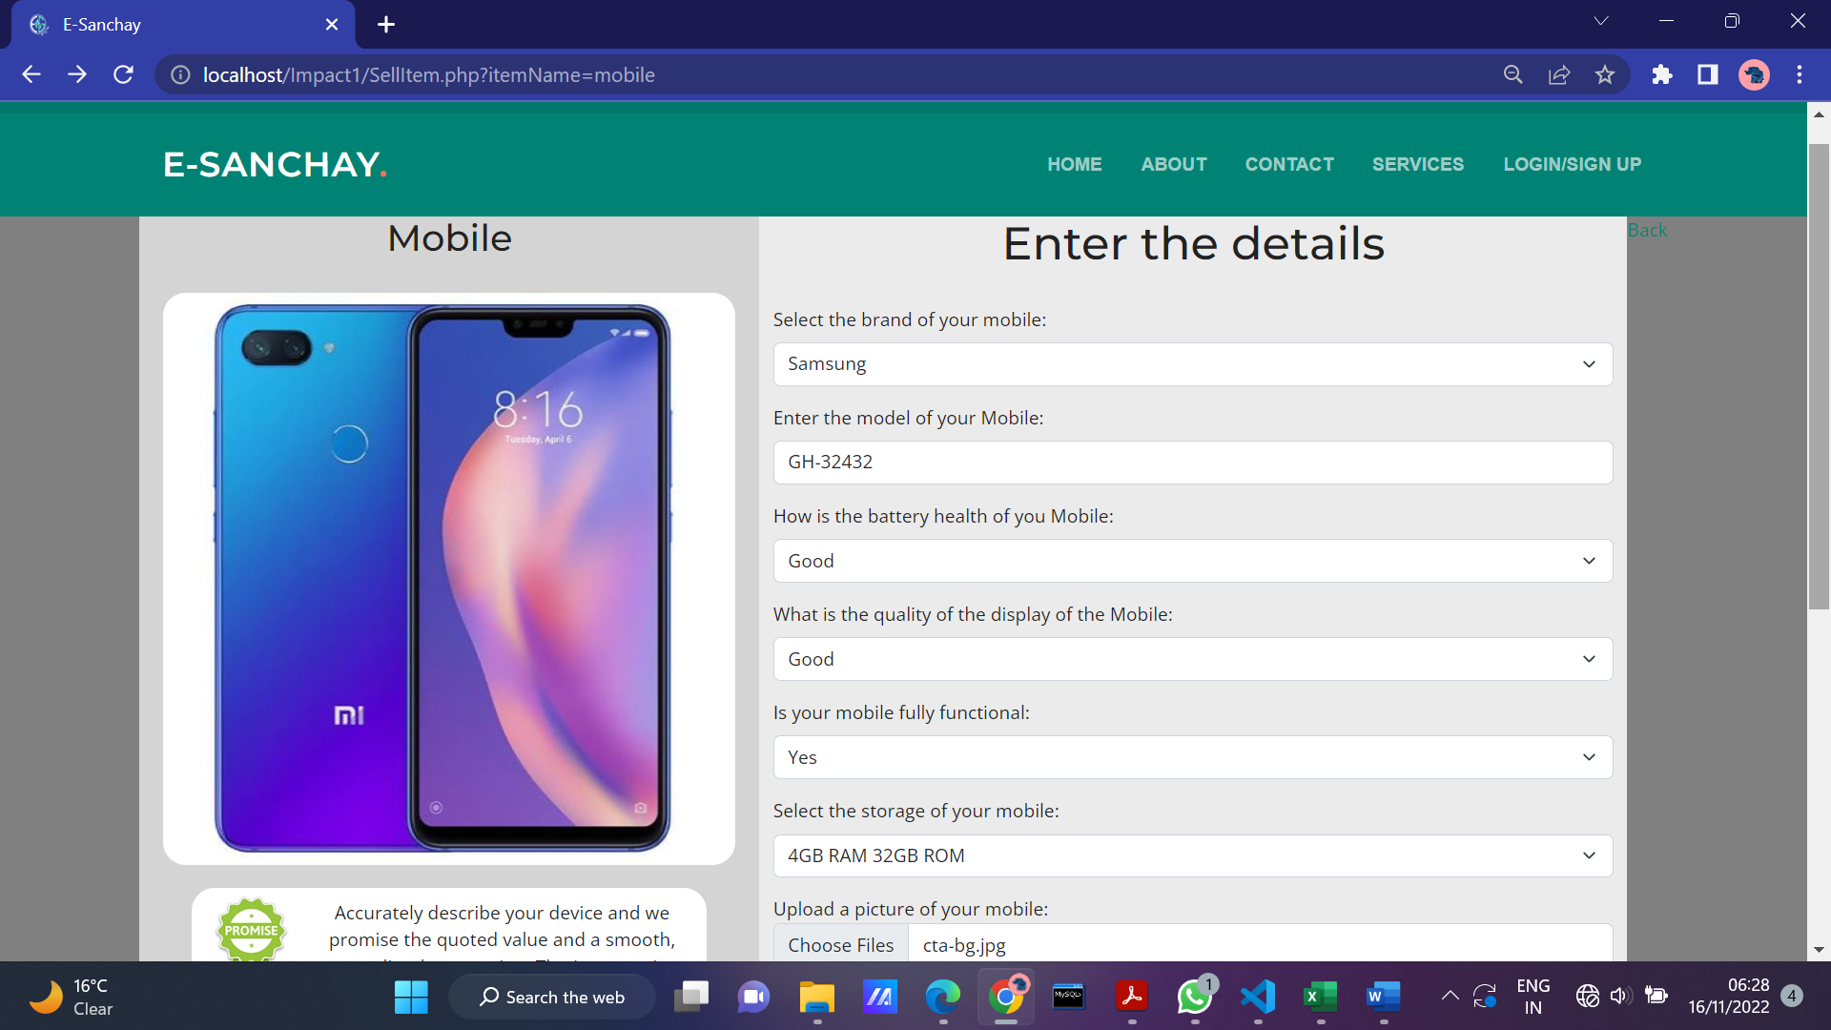

10. Selected product details is displayed🡪Login to continue

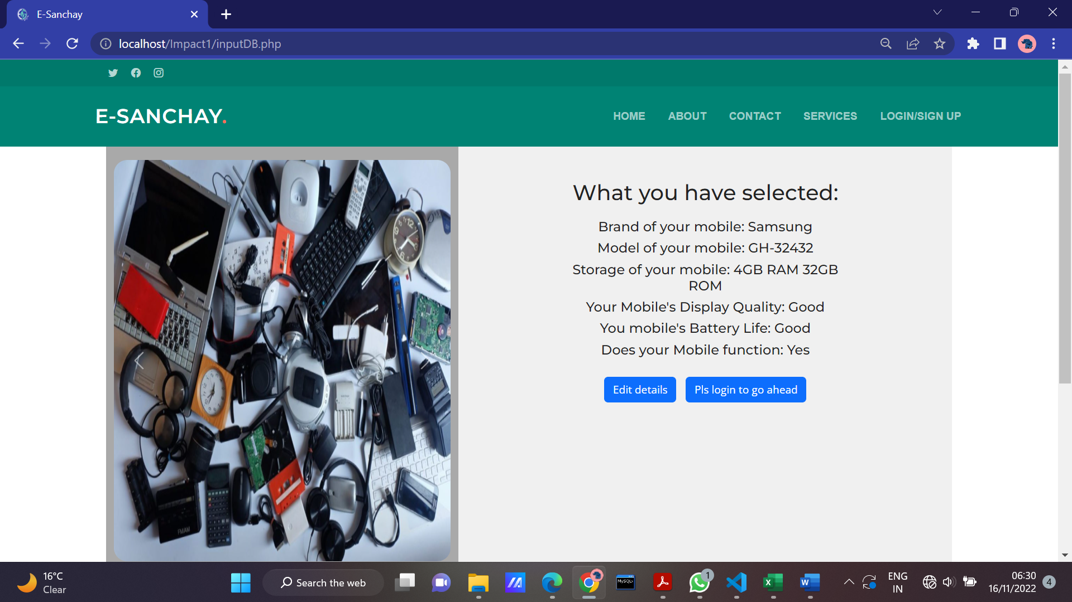

**11. Login if you are already registered**

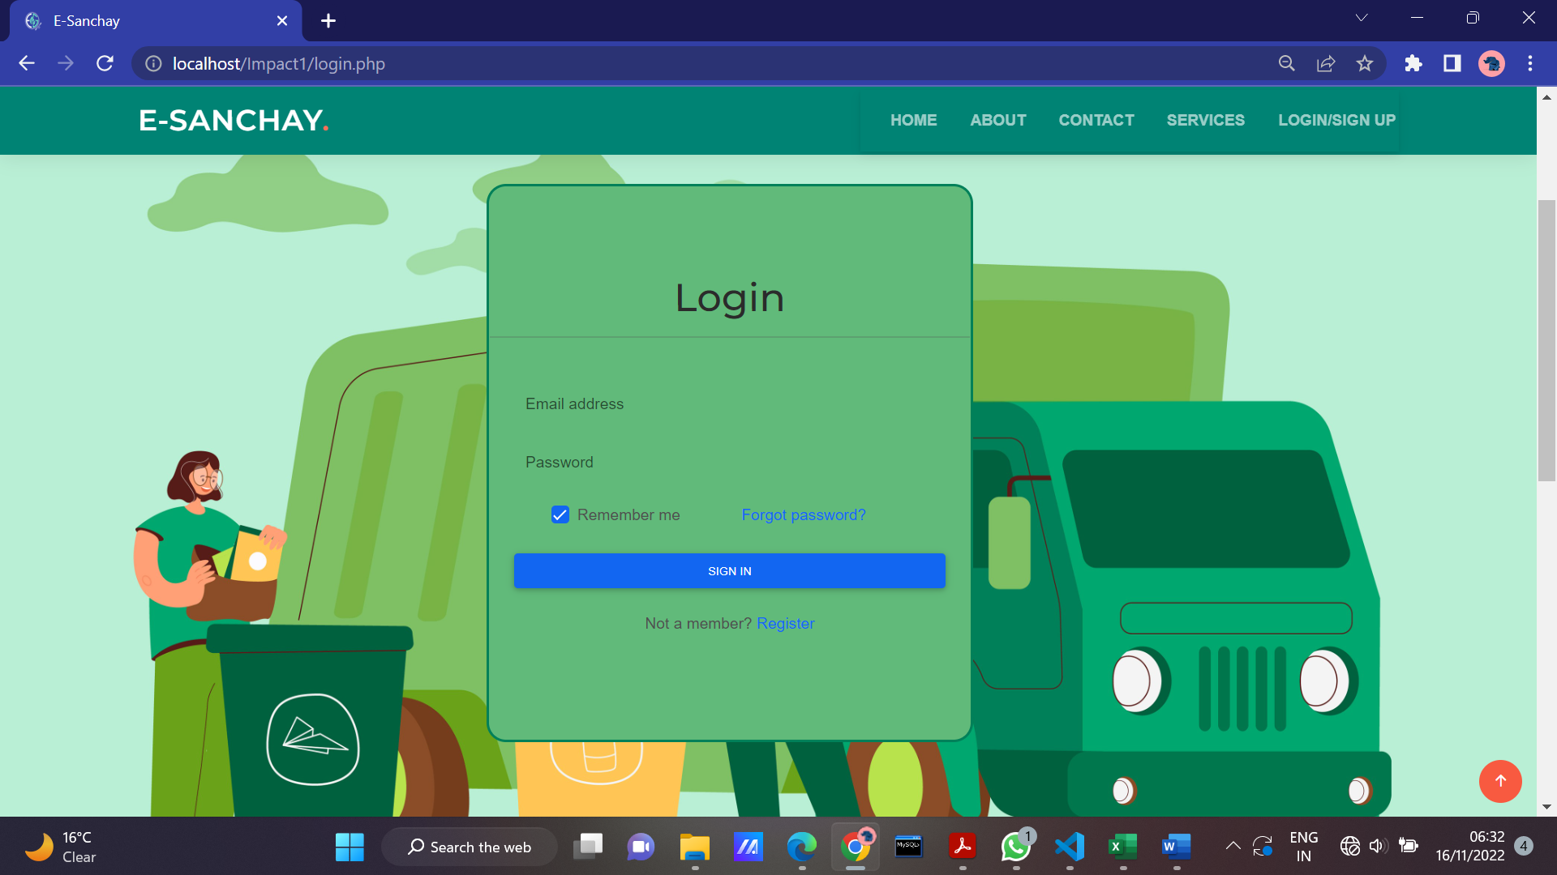

**12. Register if you have not logged in**

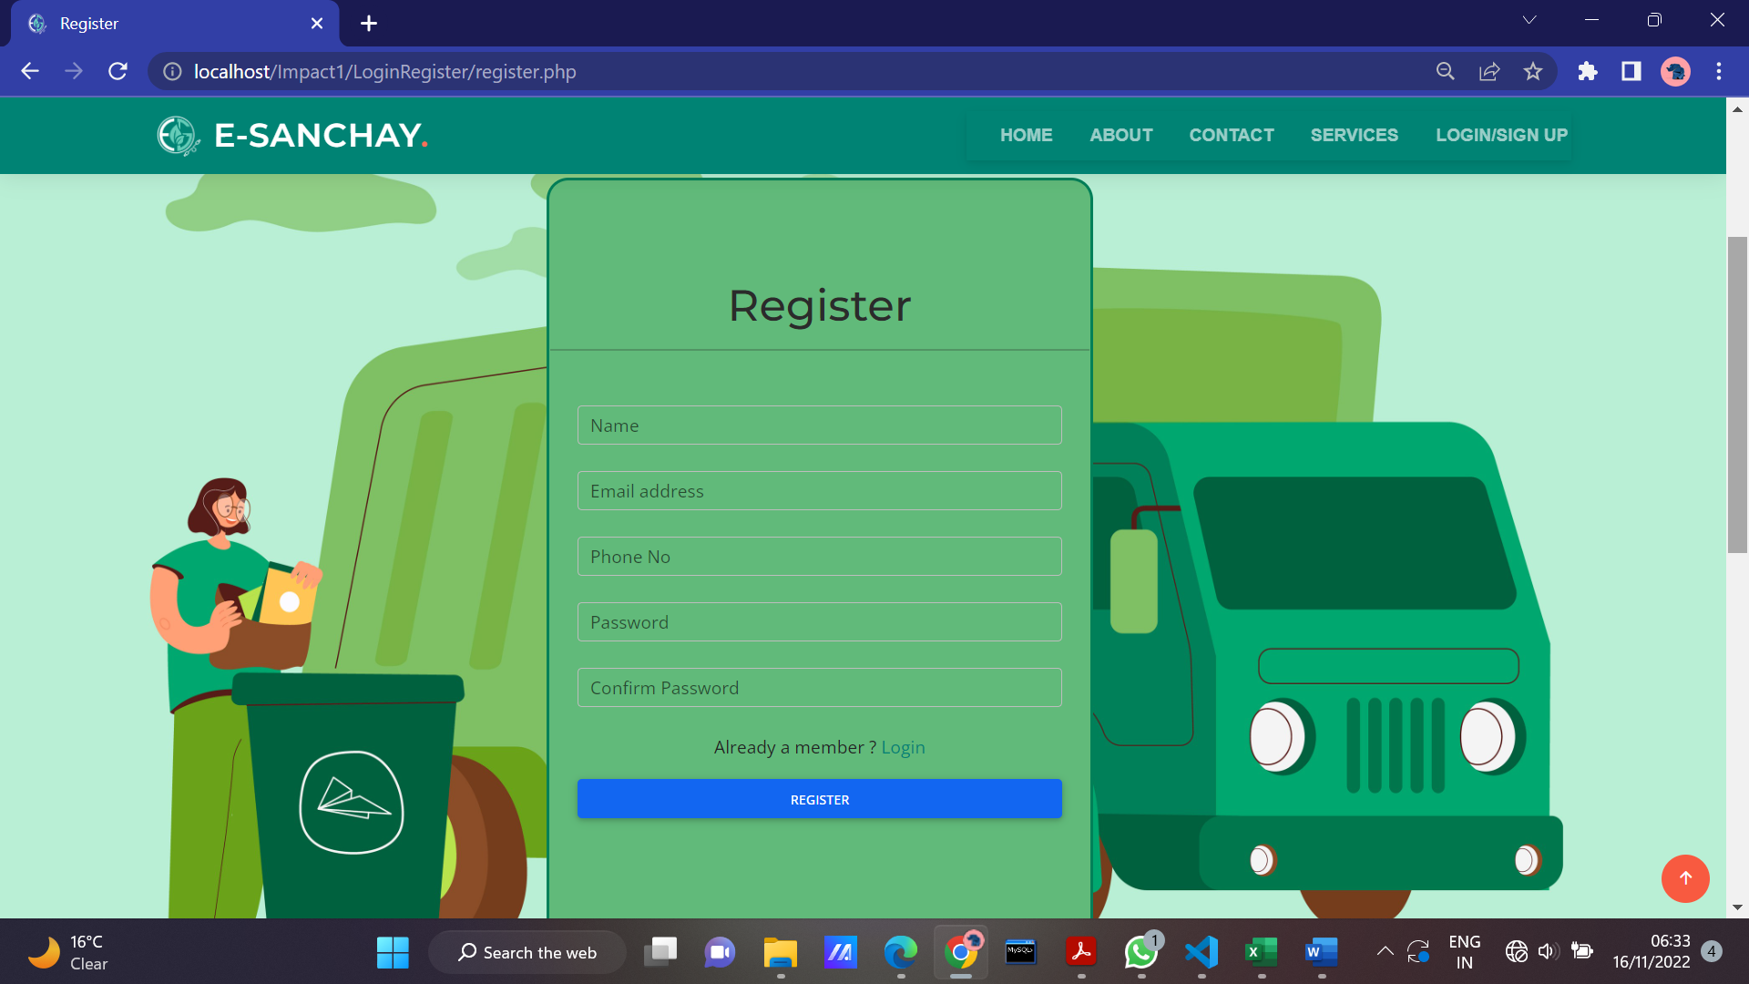

**13. Go to services page and select the product to be sold or donated. Fill in your address**

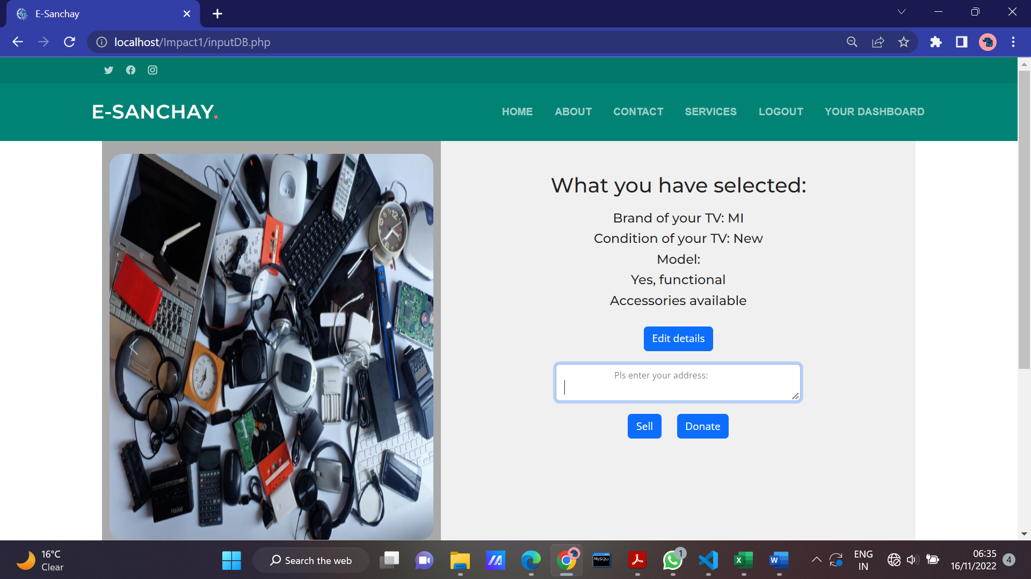**14. View Dashboard**

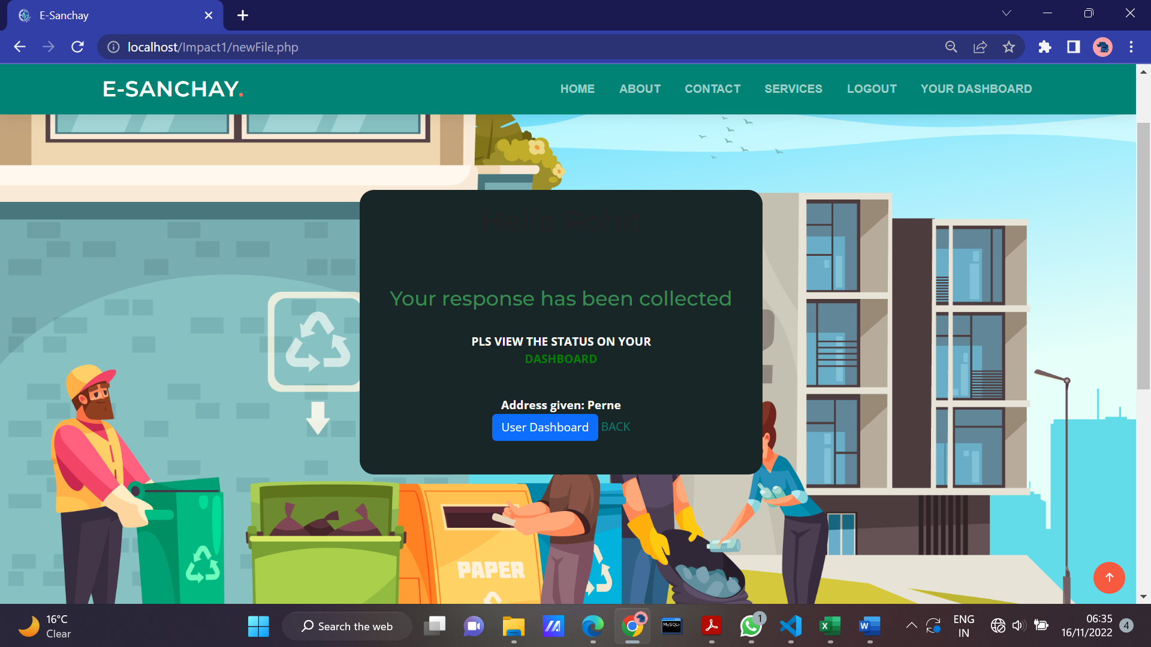  
**15. Displaying users products**

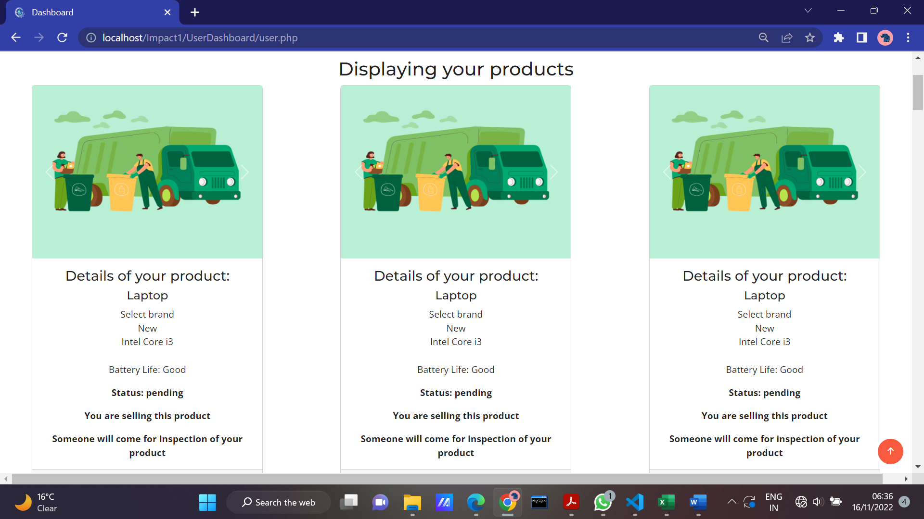

**16. Admin logs in and approve or rejects the request**

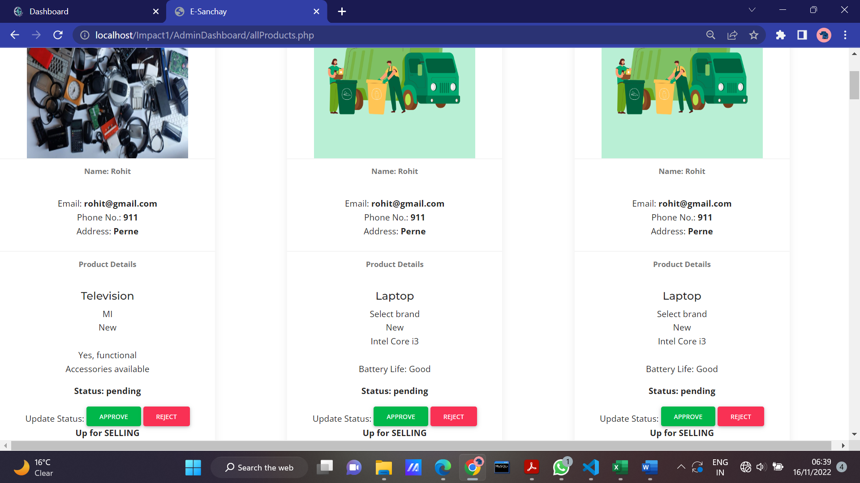

**17. After approval admin enters the exchange price**

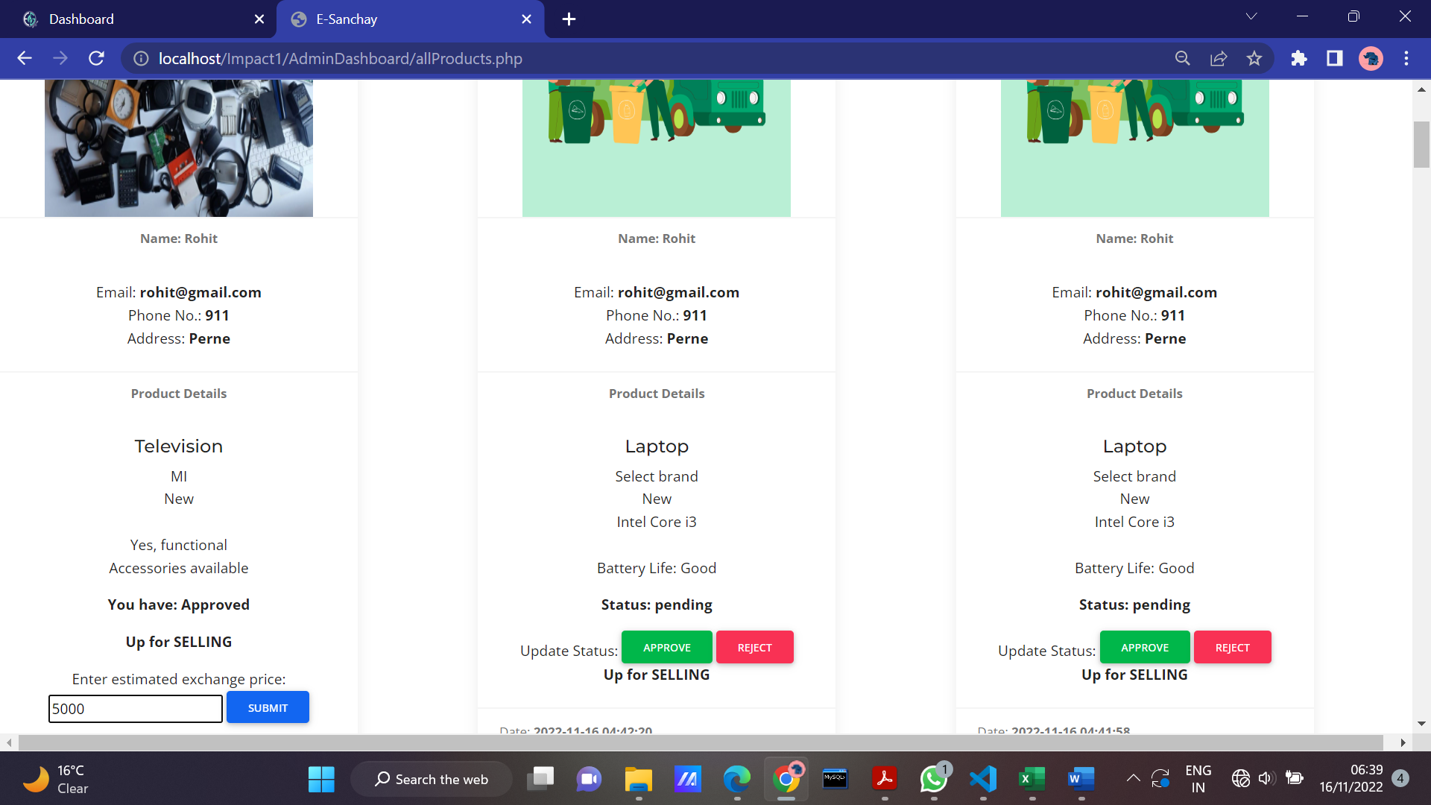

**18. User can go ahead with selling the product or reject it**

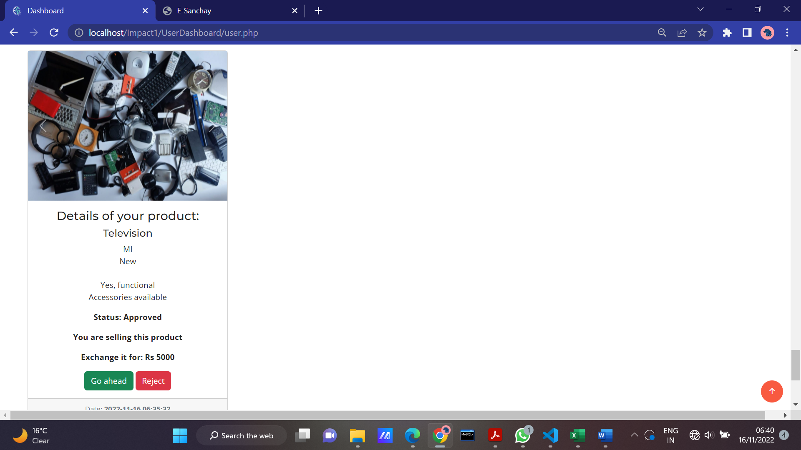

**19. If the user clicks go ahead button. The Confirmation is placed the receipt can be downloaded**

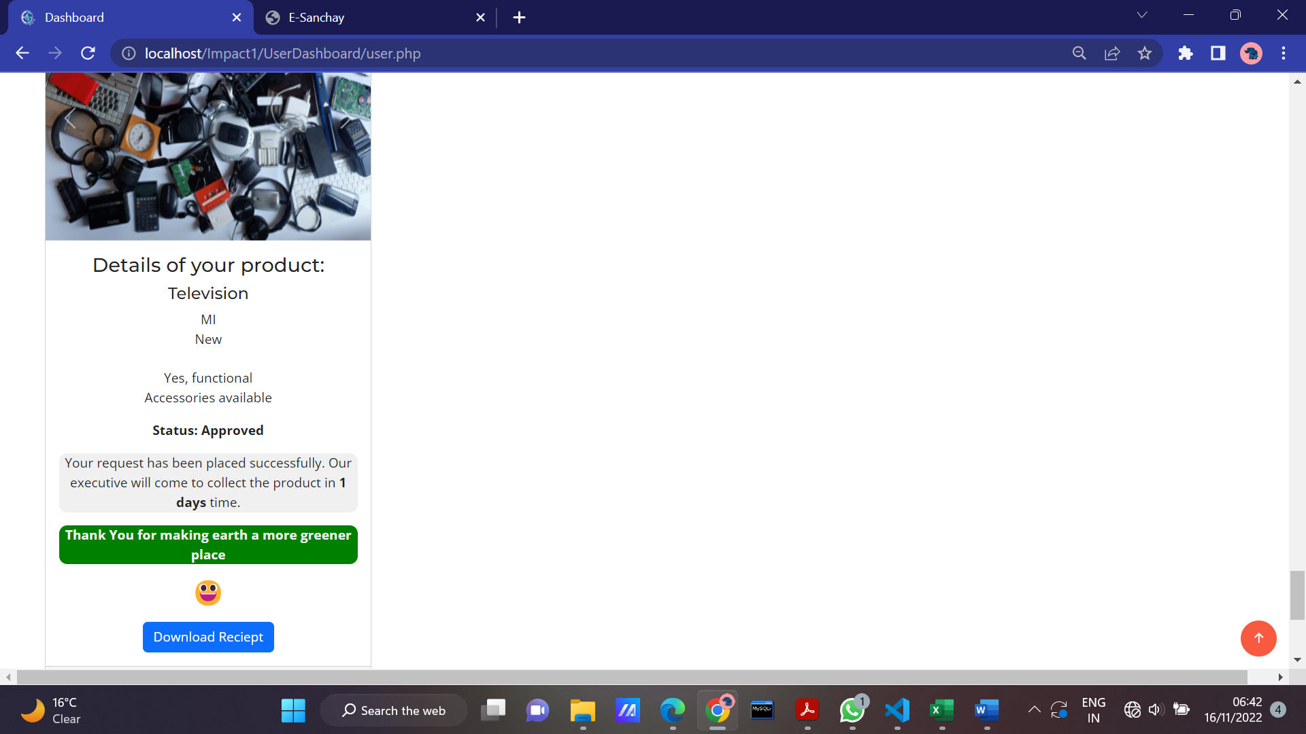

**20. Receipt is downloaded and E-Sanchay will collect the product from the address in the limits of provided days**

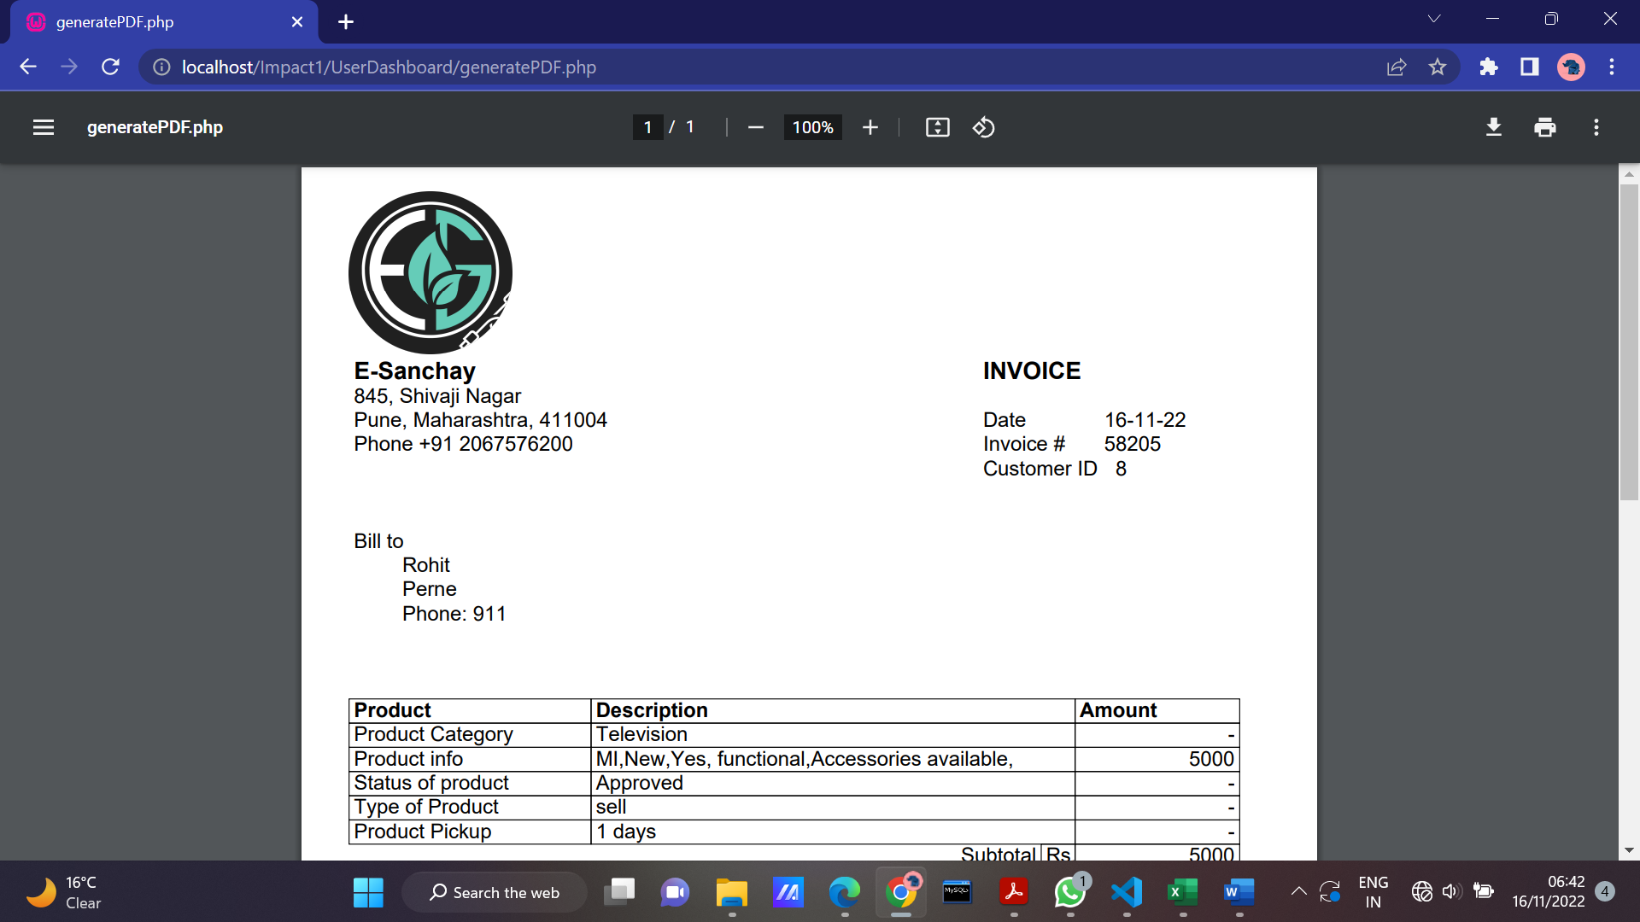

Testing Functionalities

